**Circuit Diagram & Truth Table:**

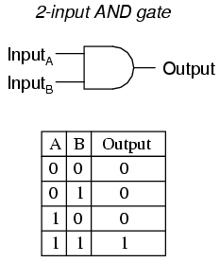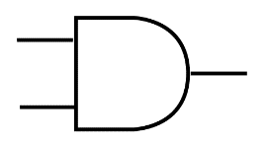

**Code:**

* **Design Module**

module gate(c,a,b);

input a,b;

output c;

assign c=a&b;

endmodule

* **TestBench**

module Baig;

reg a,b;

wire c;

gate g1(c,a,b);

initial

begin

a=1'b0;b=1'b0;

#20

a=1'b0;b=1'b1;

#20

a=1'b1;b=1'b0;

#20

a=1'b1;b=1'b1;

#20

$finish;

end

endmodule

**Output:**

